**My To Do List App**Author: Rehema Isimbi  
Date: November 2025

### **1. Introduction**

My To Do List is a full-stack web application that helps users organize their daily tasks and manage their profile. It includes a splash home page, a public listing page, and secure login with session-based authentication. The app was built entirely by me, covering both frontend and backend development.

### **2. Splash Home Page**

The splash home page is the first page users see when they visit the app. It shows a motivational message and a “Get Started” button. This page sets the tone of the app and invites users to register or log in.

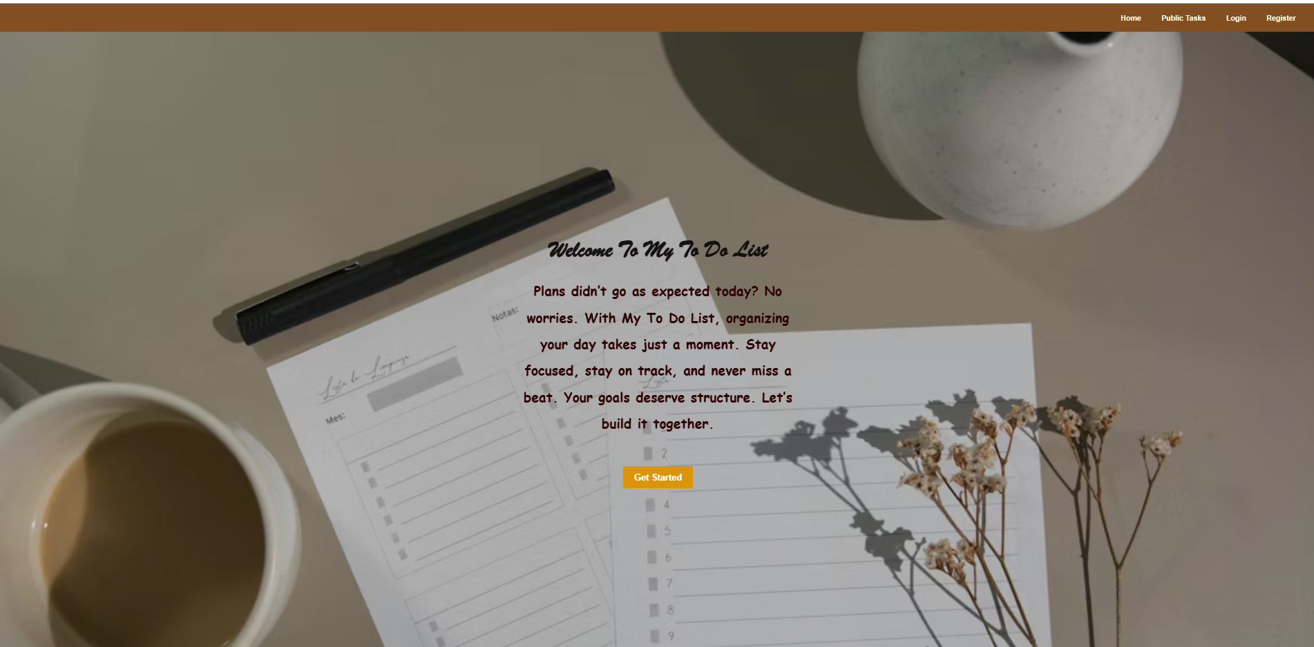

### **3. Public Listing Page**

The public listing page shows all tasks without requiring login. Anyone can visit /tasks/public and see the tasks displayed in a grid format. This satisfies the requirement for a public page that is accessible to everyone.

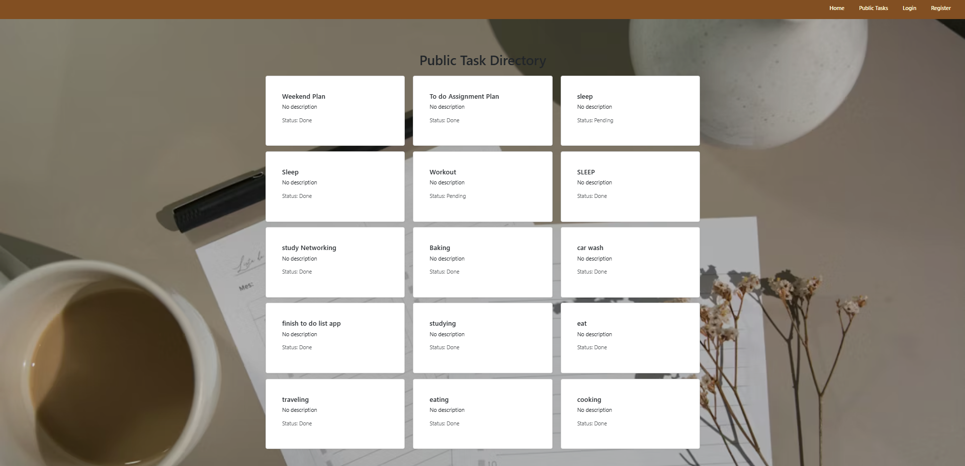

### **4. Authentication and Profile**

Users can register, log in, and log out of the app. Once logged in, they can view and update their profile information or delete their account. These routes are protected by middleware to make sure only logged-in users can access them.

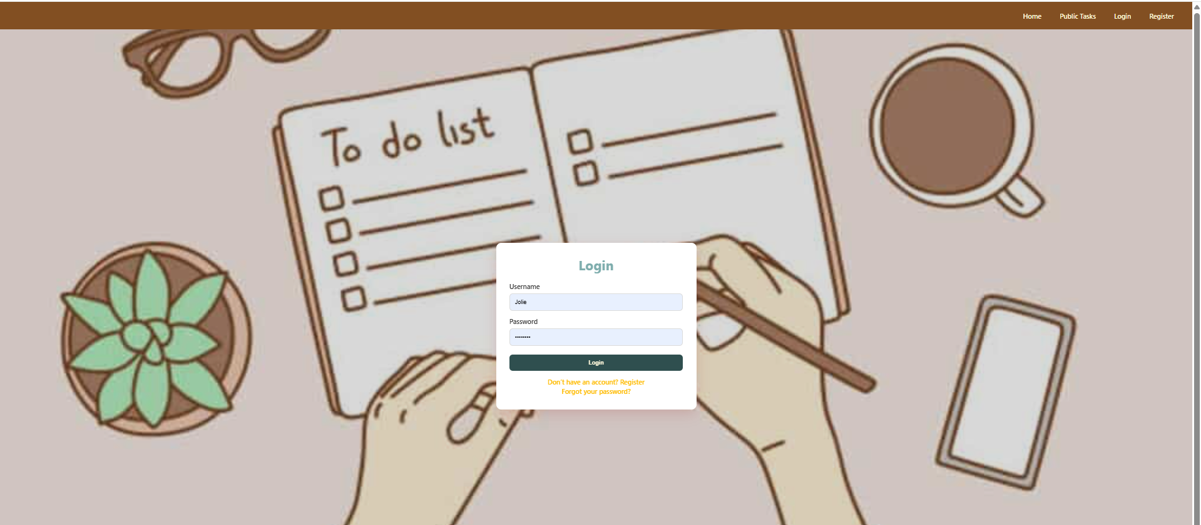*Login page*

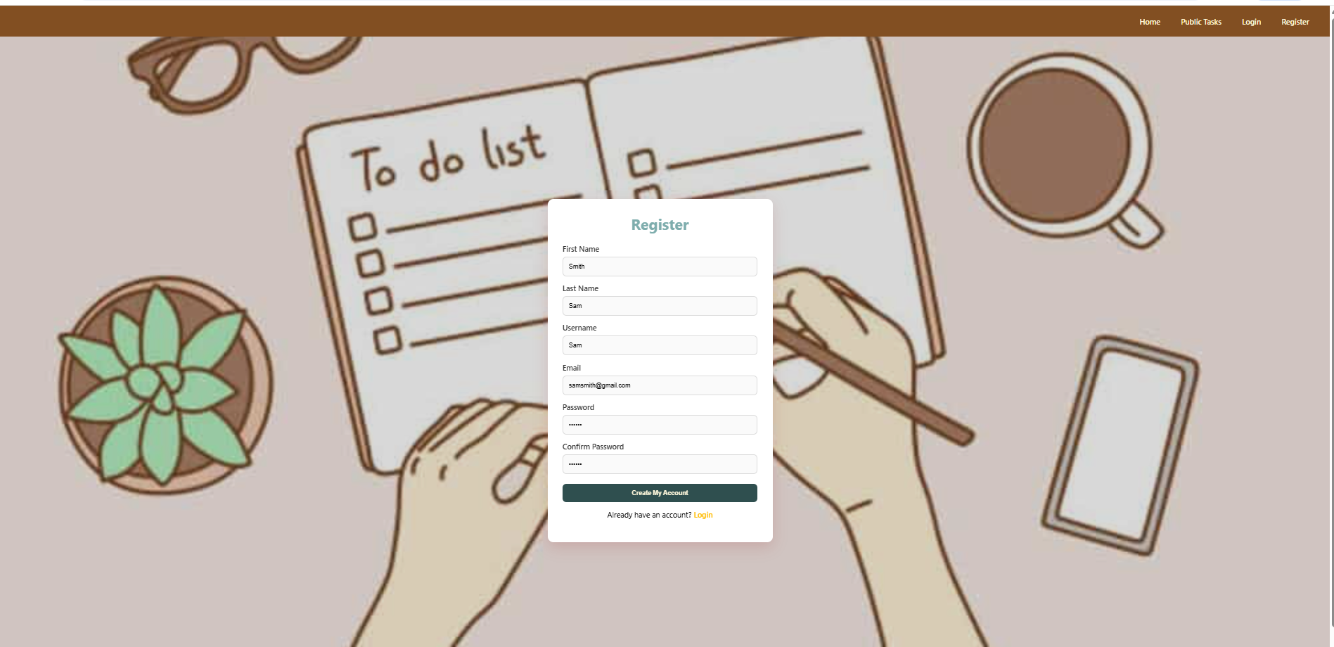

*Register page*

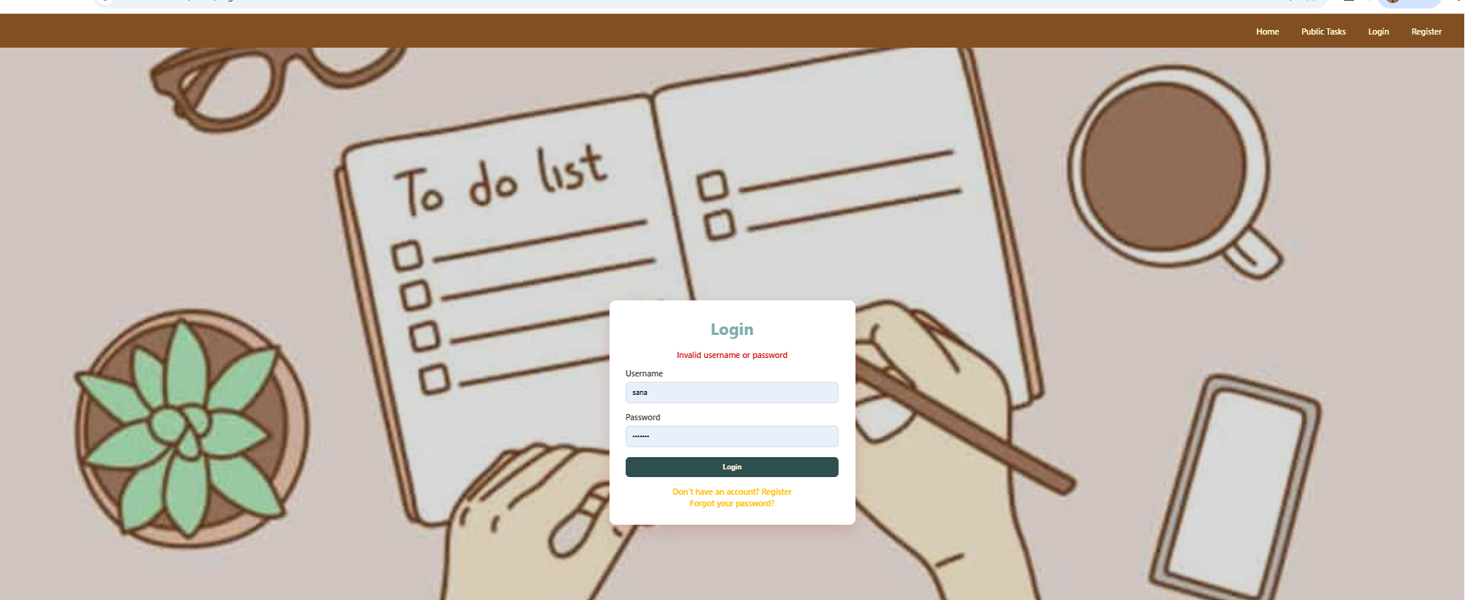

*Invalid login*

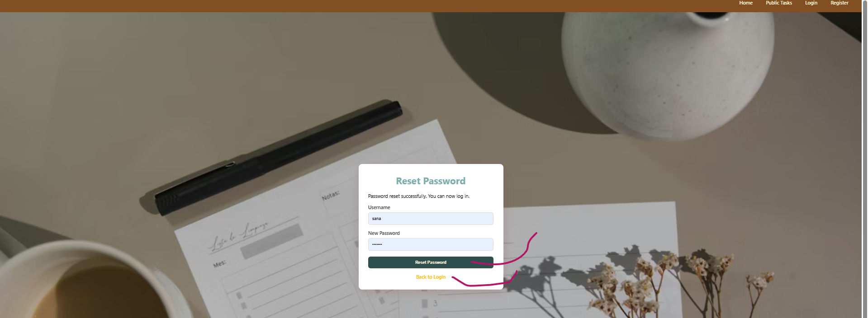

*Reset password*

### **5. Task CRUD**

The app supports full CRUD functionality for tasks. Users can create new tasks, view them, update their status, and delete them. When deleting, a confirmation prompt appears to accidental deletions.

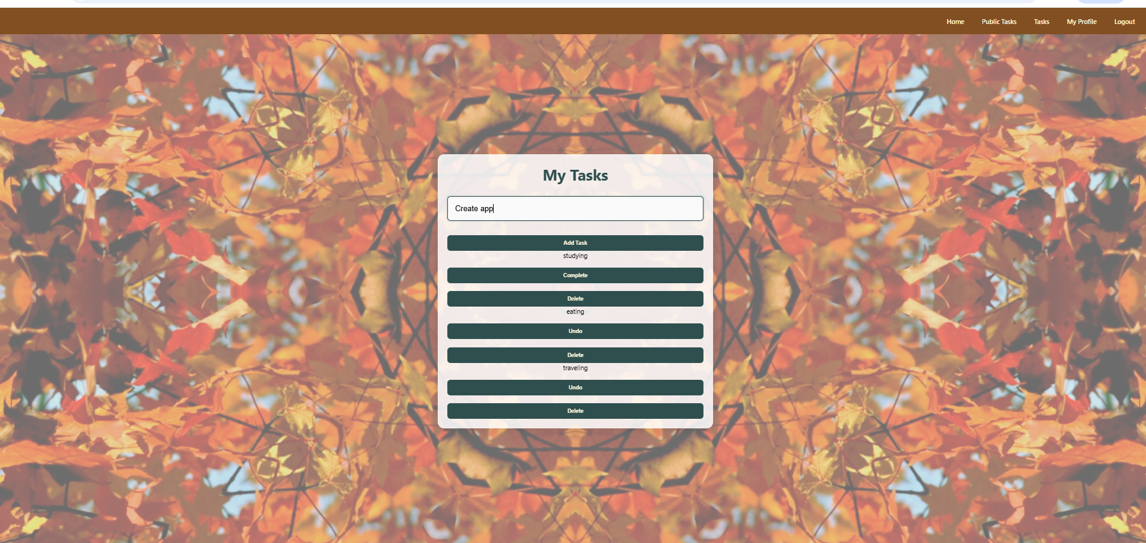

### **6. Middleware Protection**

Middleware is used to protect private routes. The middleware checks if a user is logged in before allowing access to pages like /tasks and /auth/profile. If the user is not logged in, they are redirected to the login page.

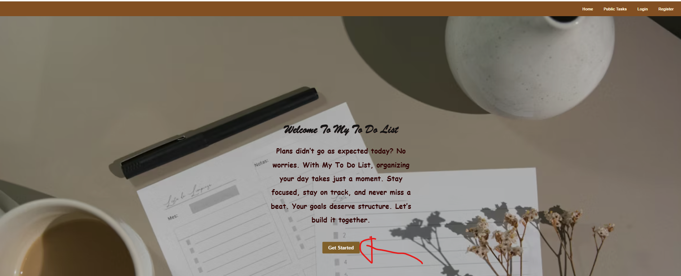

*Press get started*

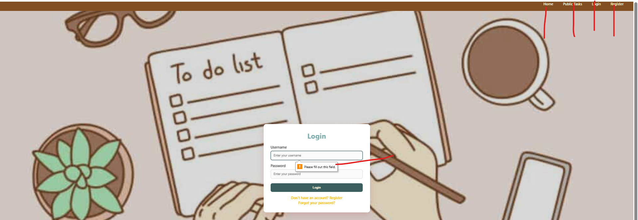

*Login in order to see Task*

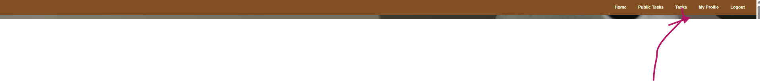

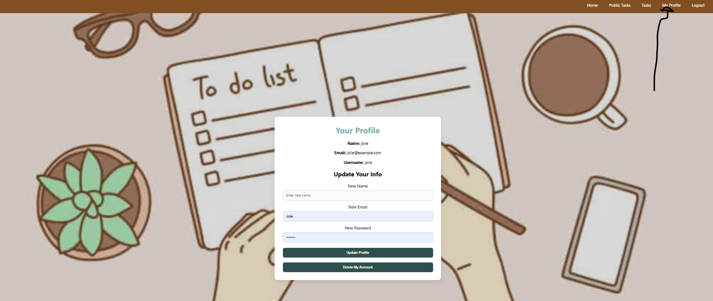

*My profile*

### 

### **7. Database Setup**

The app uses MongoDB Atlas for cloud database hosting. The connection string and session secret are stored securely in a .env file. The .env file is ignored in GitHub using .gitignore so that sensitive information is not exposed.

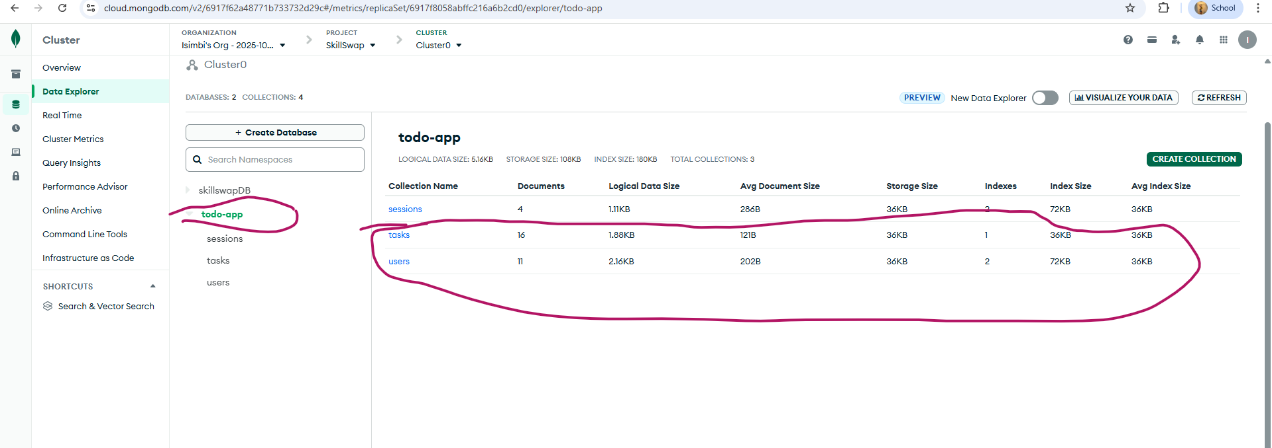

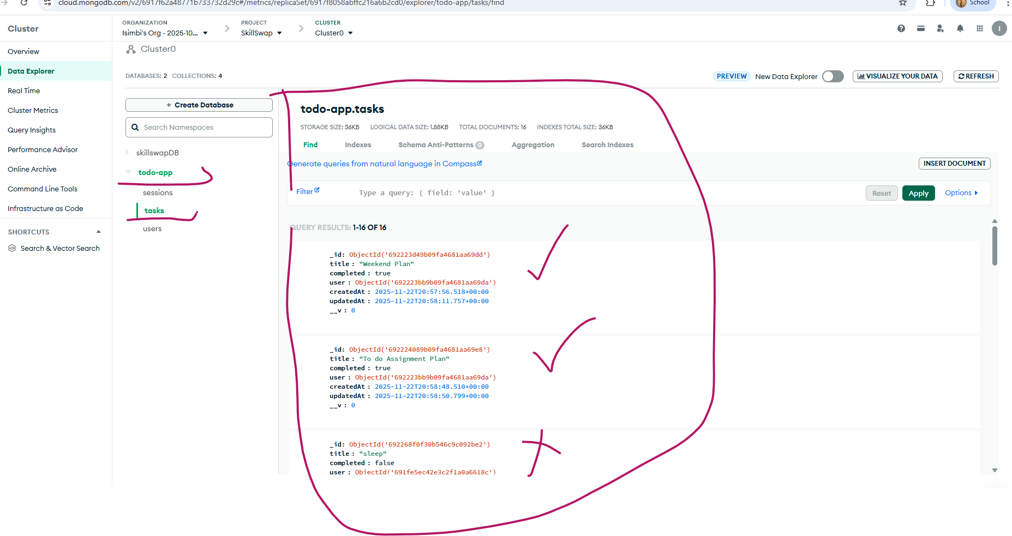

*This screenshot shows the tasks saved in my MongoDB Atlas database. Each task has a name, a completed status (true or false), and is linked to a user by their ID.*

*It proves that my app is storing task data correctly in the cloud. The format matches my Mongoose schema.*

*I keep my database connection and session secret safe using a .env file. This file is hidden from GitHub using .gitignore so no sensitive info is shared.*

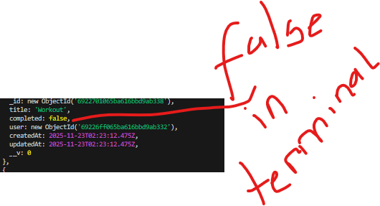

### **8. Styling**

The app uses custom CSS for styling. The file auth.css contains the styles for the pages. No Bootstrap was used, which makes the design unique and personalized.

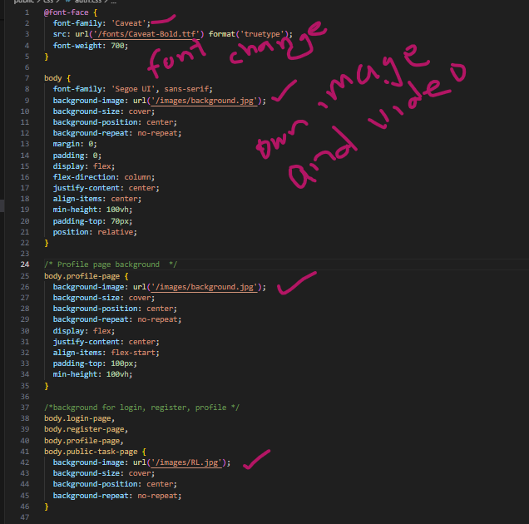

*Background image and video in auth.css*

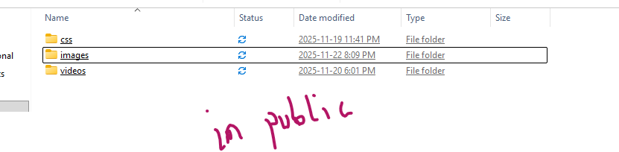

### **9. Folder Structure**

The project is organized into clear folders for models, routes, views, middleware, and public assets. This makes the app easy to maintain and understand.

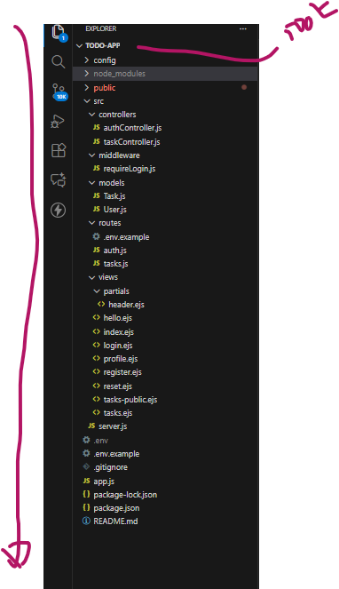

*Folder structure in VS code*

### 

### 

### 

### **Conclusion**

This project shows that I built a full-stack web app from start to finish. It includes secure login, profile management, and full task CRUD features.

The app works smoothly, looks clean, and meets all the assignment requirements. I handled both the backend and frontend, and made sure everything is safe, clear, and easy to use.

Demovideo:

<https://docs.google.com/videos/d/1ucwluHCkFI-n3HDfolKVGevCNewpqmie3p4RTCE9TbE/edit?usp=drive_link>